**Installing and Running Proj**

1. Goto

<http://www.codeblocks.org/downloads/26>

2. Download this file

**codeblocks-13.12mingw-setup.exe**

3. Install it

4. Write a basic C program by

     a) Goto File ->New-> File-> C/C++ Source->Go->Next-> Select C-> Next

     b) In the file name with full path click ... button

     c) Select a directory in which you want to save program

     d) Write the name of prog with .C extension e.g., first.c

     e) Click save

     f)  Write a simple C prog

     g) Goto Build

     h) Click build and run

If everything is all right your program will execute.

***NOTE: Do not include <conio.h> and use clrscr() & getch() functions***

In order to run your proj

1. Open codeblocks

2. Goto Settings-> click compiler-> click other options

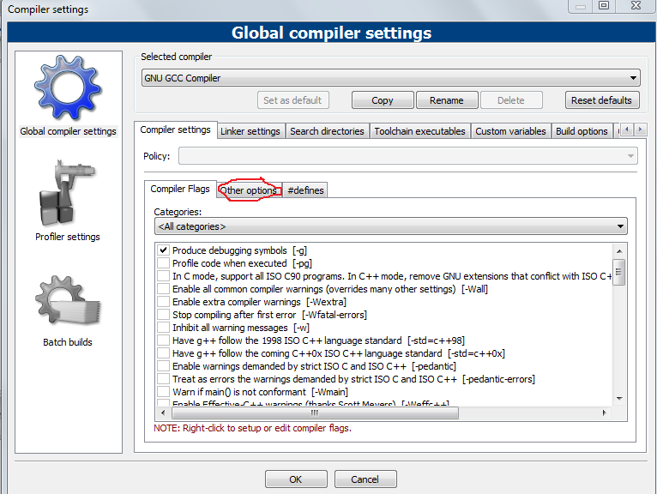

3. Write -std=c99

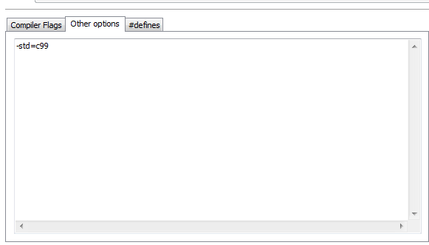

click ok

4. Extract the zip file sent to you in a directory e.g., Desktop

5. Goto File-> open->Goto Directory in which project is extracted->Click Clustering (project file)-> Open

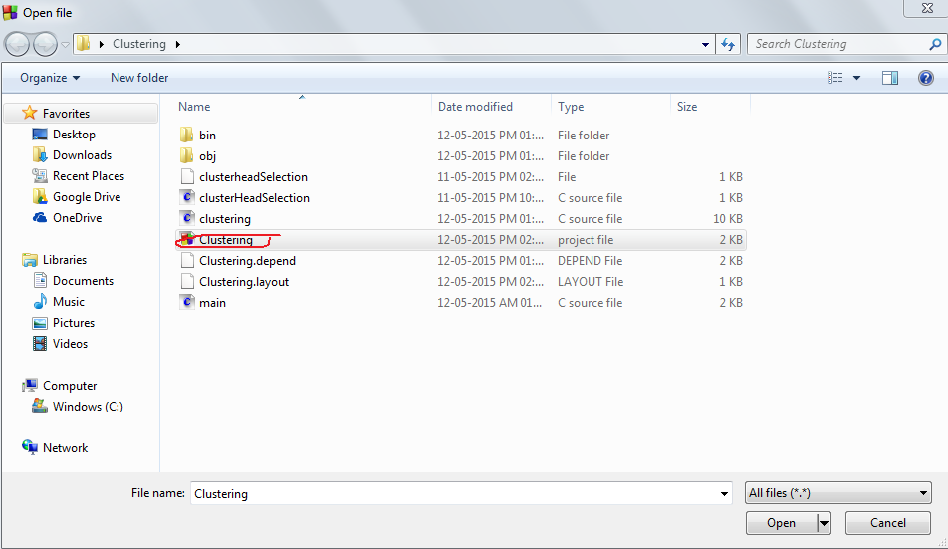

6. Goto- Build-> Click Build and Run

**Sample Output:**

